

24ADC001- BUSINESS INTELLIGENCE

THARUN – 24BAD126
--------------------------------------------------

2026-2027
LAB RECORD

DEPARTMENT OF ARTIFICIAL INTELLIGENCE AND DATA SCIENCE

INDEX
Expt. No | Title of the Experiment | Page No | Total Marks | Faculty Signature
1. | Explore the interface and basic features of the BI tool
2. | Load and visualize a sample dataset.
3. | Import a dataset into the BI tool. And Cleanse data by handling missing values, outliers, and  inconsistencies.
4. | Transform data to suit BI reporting requirements and Design a dashboard with  key performance indicators (KPIs).
5. | Develop interactive dashboards for dynamic data exploration.
6. | Integrate data from various sources for comprehensive analysis
7. | Implement advanced chart types (treemaps, heatmaps, etc.).
8. | Apply BI tools for forecasting and predictive analytics.

Average marks Faculty Signature

EXPT NO:1 | EXPLORE THE INTERFACE AND BASIC FEATURES OF BI Tool
DATE: 10.07.2026

PRE-LAB QUESTIONS (PROVIDE BRIEF ANSWERS TO THE FOLLOWING QUESTIONS)

- What is the purpose of Business Intelligence (BI) tools like Tableau and Power BI?
Their primary purpose is to transform raw, structured or unstructured data into meaningful, interactive visualizations and actionable insights for data-driven decision-making.quickly.

- List any three common data sources that Tableau and Power BI can connect to.
• Microsoft Excel files / CSVs.
• SQL Databases (e.g., MySQL, PostgreSQL, SQL Server).
• Web services and cloud sources (e.g., Google Analytics, Salesforce).

- What is a dashboard in BI, and how is it different from a single chart?
• A dashboard is a consolidated presentation of multiple charts, tables, and KPIs on a single screen to offer a comprehensive overview.
• A single chart displays only one specific data view or relationship (e.g., a single line graph of prices over time).
- Define the following terms:
a) Visualization: The graphical representation of data and information (using charts, graphs, maps) to make patterns and trends easier to understand.
b) KPI (Key Performance Indicator): A quantifiable metric used to evaluate performance against specific goals or benchmarks (e.g., average prediction error or total sales).
c) Data Filter: A tool used to restrict or isolate a subset of data displayed in a visual based on chosen criteria (e.g., filtering by a specific year or product category).

- Why is it important to clean and transform data before visualization?
Visualizing dirty data (missing values, duplicates, outliers) leads to false trends and incorrect business decisions. Clean data ensures accuracy and reliability.

- What kind of chart would you use to analyze stock price trends over time?
A Line Chart is best for showing continuous data over a time series.

- Explain the role of slicers in Power BI and filters in Tableau.
Both allow users to dynamically segment and refine the data shown across visuals on a dashboard/report page based on chosen criteria (e.g., selecting a specific stock or date range).

- What does a calculated field or measure do in BI tools?
TIt creates new, custom fields or metrics by applying mathematical or logical formulas (like DAX in Power BI) onto existing columns in the dataset.

- What are the advantages of using interactive dashboards for financial data analysis?
Enables dynamic exploration, allows quick drill-downs into specific timeframes or assets, speeds up risk detection, and improves decision-making accuracy.

- Which function would you use to find the absolute difference between predicted and actual stock prices?

The ABS() (Absolute) function along with subtraction: ABS(Predicted - Close).

IN-LAB EXERCISE:
Objective:
To understand the basic interface, data import process, and fundamental visualization capabilities of Tableau and Power BI using a stock prediction dataset, and to explore their usefulness in analyzing financial data.

Tools Required:
- Tableau Public / Tableau Desktop
- Power BI Desktop
- Sample Dataset (CSV/Excel) containing:
Date, Stock Name, Open, Close, High, Low, Volume, Predicted Price

Exercise Steps:
Part 1: Working with Tableau
- Launch Tableau and connect to the stock prediction dataset.

Explore the Interface:
  - Understand components like Data Pane, Sheets, Marks Card, and Dashboards.

Create Basic Visualizations:
  - Line Chart: Show Close Price over time.
  - Scatter Plot: Plot Volume vs. Predicted Price.
  - Highlight Table: Display Predicted Price by stock.

Apply Filters:
  - Add filters for Stock Name and Date Range.

Create Calculated Field:
  - Calculate prediction error as |Predicted - Close|.

Design a Basic Dashboard:
  - Combine your charts into one interactive dashboard.
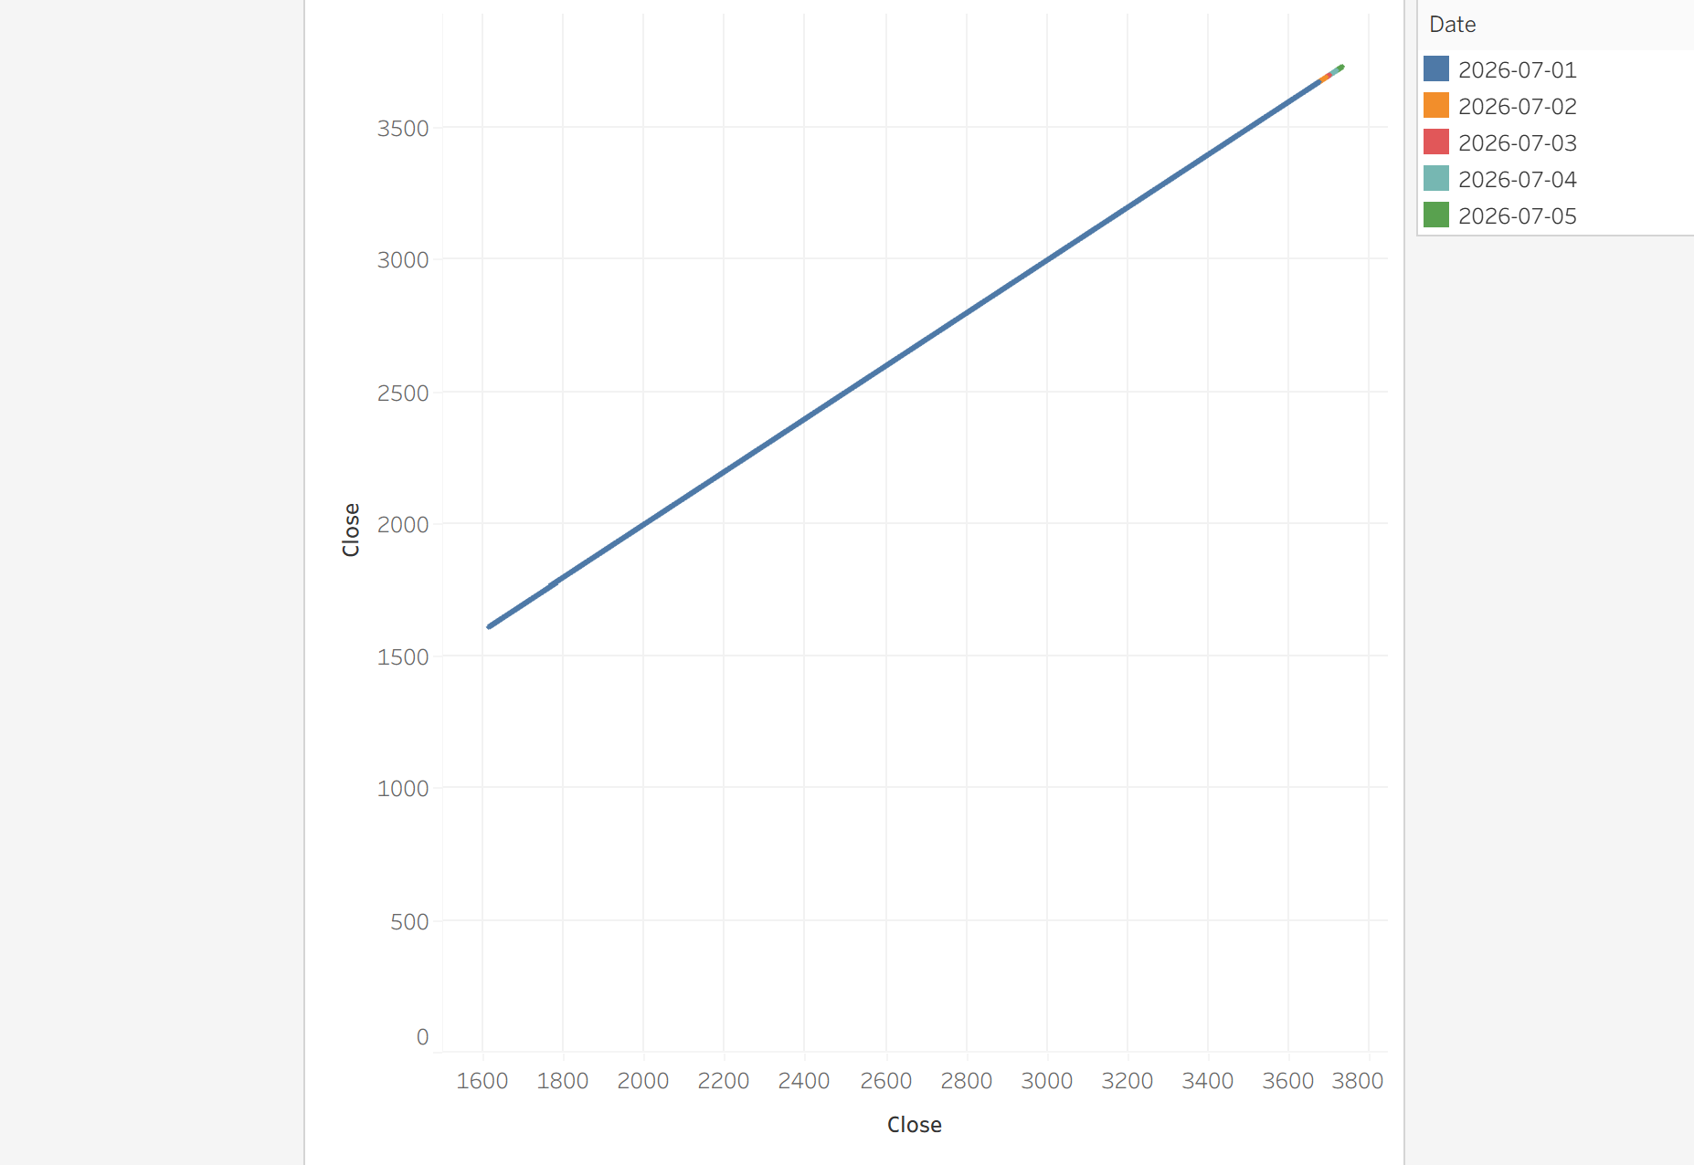

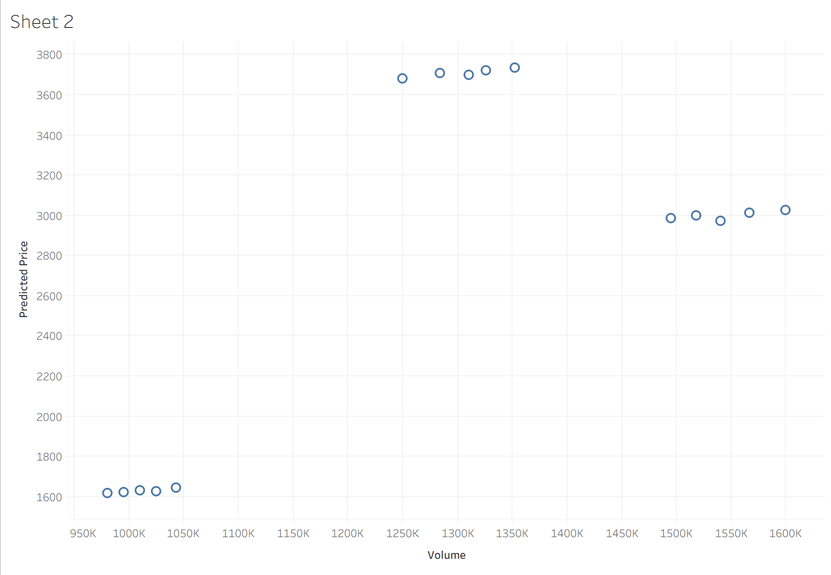

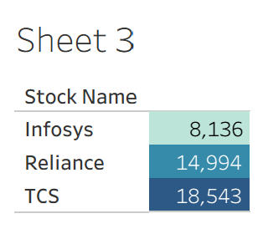

Part 2: Working with Power BI
- Open Power BI Desktop and import the same dataset.

Explore the Interface:
  - Familiarize with Fields Pane, Visualizations Pane, Report View, Data View.

Create Basic Visualizations:
  - Line Chart: Trend of Close Price over time.
  - Bar Chart: Compare Predicted Price vs. Close Price.
  - Card (KPI): Display average prediction error.

Use Filters and Slicers:
  - Filter data based on Stock Name and Date.
- Create a Simple Measure using DAX:
  - Example: Prediction Error = ABS(Predicted - Close)

Build a Report Page:
  - Arrange visuals in a single interactive page

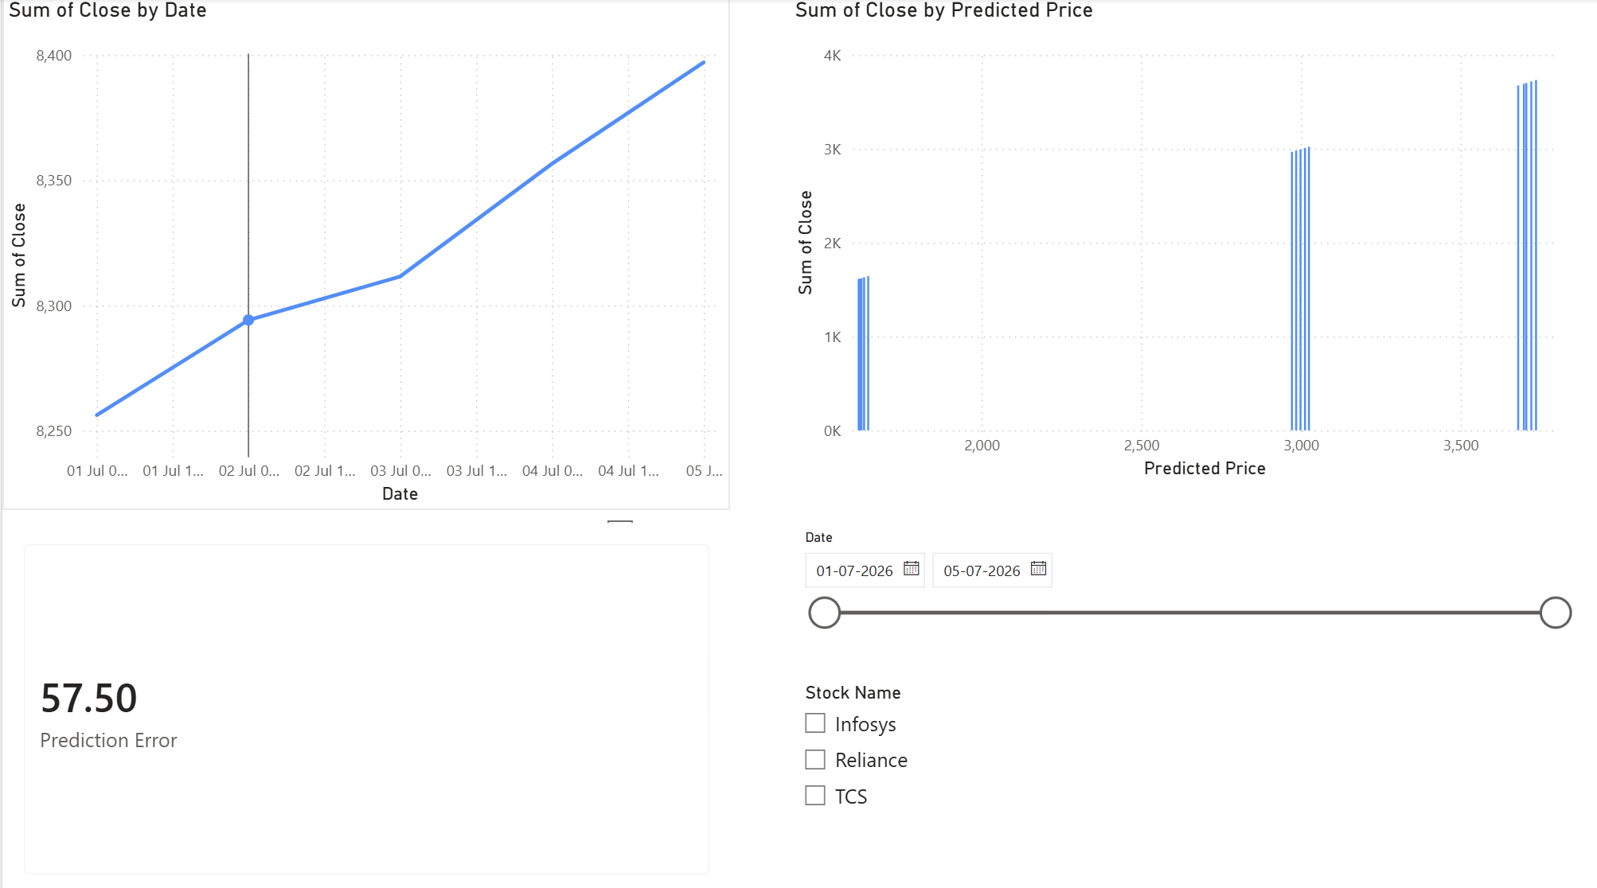.

POST-LAB QUESTIONS (PROVIDE BRIEF ANSWERS TO THE FOLLOWING QUESTIONS)
- Describe your experience with the Tableau interface. What components did you interact with?
Interacted with the Data Pane (dimensions & measures), Marks Card (color, size, label formatting), Shelves (Columns and Rows), Sheets (individual visuals), and the Dashboard Canvas.

- How did you import the dataset into Tableau and Power BI?
• tableau: Selected "To a File" $→$ "Text File" / "Microsoft Excel" on the start page and connected to the stock CSV/Excel file.
• Power BI: Used the "Get Data" button on the Home ribbon, chose "Excel Workbook" / "Text/CSV", selected the file, and clicked "Load

- What types of visualizations did you create in both tools? List at least two per tool.
• Tableau: Line Chart (Close Price over time) and Scatter Plot (Volume vs. Predicted Price).
• Power BI: Line Chart (Close Price trend) and Bar Chart (Predicted Price vs. Close Price)

- How did you calculate the prediction error, and how was it displayed in your dashboard?
• Calculated using ABS([Predicted Price] - [Close]).
• Displayed using a Card visual in Power BI (to show average error) and included as a metric/tooltip on the Tableau dashboard.
• Calculated using ABS([Predicted Price] - [Close]).
• Displayed using a Card visual in Power BI (to show average error) and included as a metric/tooltip on the Tableau dashboard.

- Which filtering or slicing techniques did you apply, and what insights did they reveal?
Applied Stock Name and Date Range filters/slicers. They revealed individual stock trajectory performance over specific months and showed how prediction accuracy varied across different volatile trading days.

- Compare the process of creating a line chart in Tableau vs. Power BI. What differences did you notice?
• tableau: Dragged fields directly to "Columns" (Date) and "Rows" (Close Price) shelves.
• Power BI: Selected the Line Chart visual icon first, then dragged fields into specific field wells (X-axis, Y-axis) in the Visualizations pane.

- How did you organize the dashboard in Tableau and Power BI? What key elements did you include?
Arranged visuals logically with high-level KPI cards at the top, trend/line charts in the center, and slicers/filters on the side/top for interactive filtering across all views.

- Which tool (Tableau or Power BI) did you find more user-friendly for financial data visualization, and why?
Sample answer: Power BI felt more intuitive for building quick reports and using DAX metrics, whereas Tableau excelled in smooth visual drag-and-drop mechanics and custom formatting.

- What challenges did you face while creating visualizations or dashboards?
Ensuring date formats were correctly recognized, setting up filter actions across all sheets simultaneously, and properly calculating measures without aggregation errors.

- How can the knowledge gained from this lab be applied to real-world financial data analysis?
It enables the creation of real-time financial tracking systems, portfolio monitoring tools, and automated forecast error analyses for investment strategies.

GITHUB - https://github.com/tharun2128/24ADC001--BUISNESS-INTELLIGENCE

ASSESSMENT

Description | Max Marks | Marks  Awarded
Pre Lab Exercise | 5
In Lab Exercise | 10
Post Lab Exercise | 5
Viva | 10
Total | 30
Faculty Signature

